An Artificial Intelligence Framework for Automated Research Paper Evaluation

In this paper we are utilizing OCR, Image Processing and Artificial Intelligence algorithms like KNN to evaluate student answer with correct answer to compute scoring marks. In propose work user can upload scanned subjective or multiple choice question papers and then image processing and OCR technique will be applied to extract answers and then apply Artificial Intelligence algorithm to calculate scoring percentage based on correct answer and student answer.
To implement this project we have designed following modules
- New User Sign up: using this module user can sign up with the application
- User Login: user can login to system
- Evaluate MCQ Paper: using this module user can upload MCQ paper and then system will evaluate paper and give score
- Evaluate Subjective Paper: using this module user can enter subjective correct answer and then upload scanned copy of student subjective answer and then employ AI algorithm to give score.
SCREEN SHOTS
To run project install MYSQL database and then copy content from ‘database.txt’ file and paste in MYSQL console to create database. Install python 3.7.2 and then install all packages from requirements.txt file and then double click on ‘runWebServer.bat’ file to start python web server and then will get below page
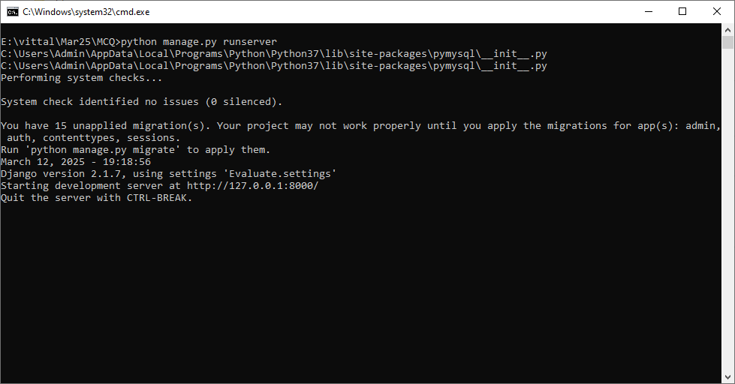
In above screen python server started and now open browser and enter URL as http://127.0.0.1:8000/index.html and then press enter key to get below page
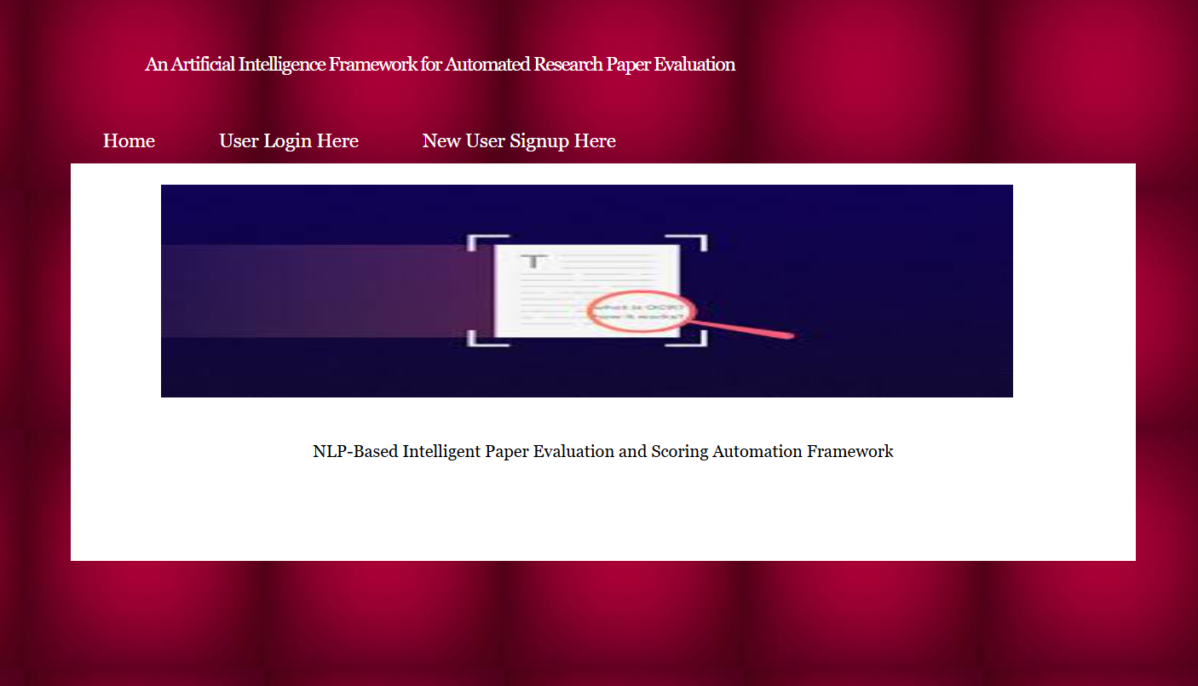
In above screen click on ‘New User Sign up’ link to get below page
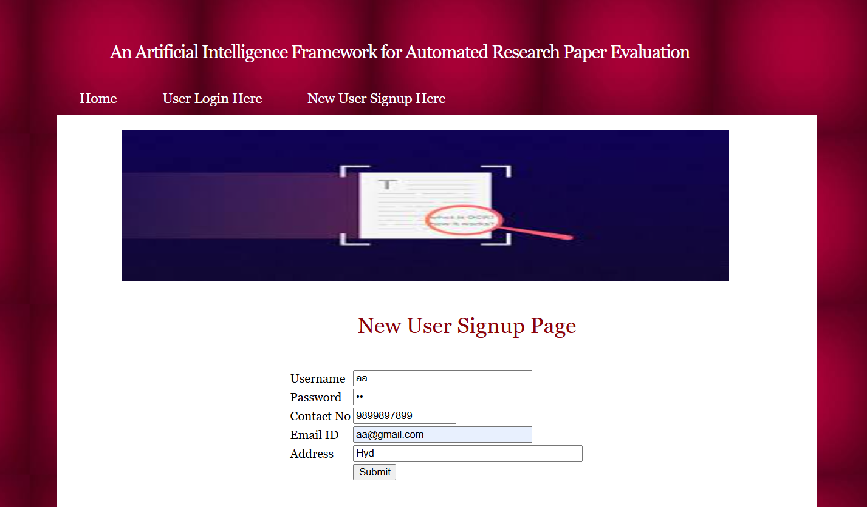
In above screen user is entering sign up details and then press button to get below page
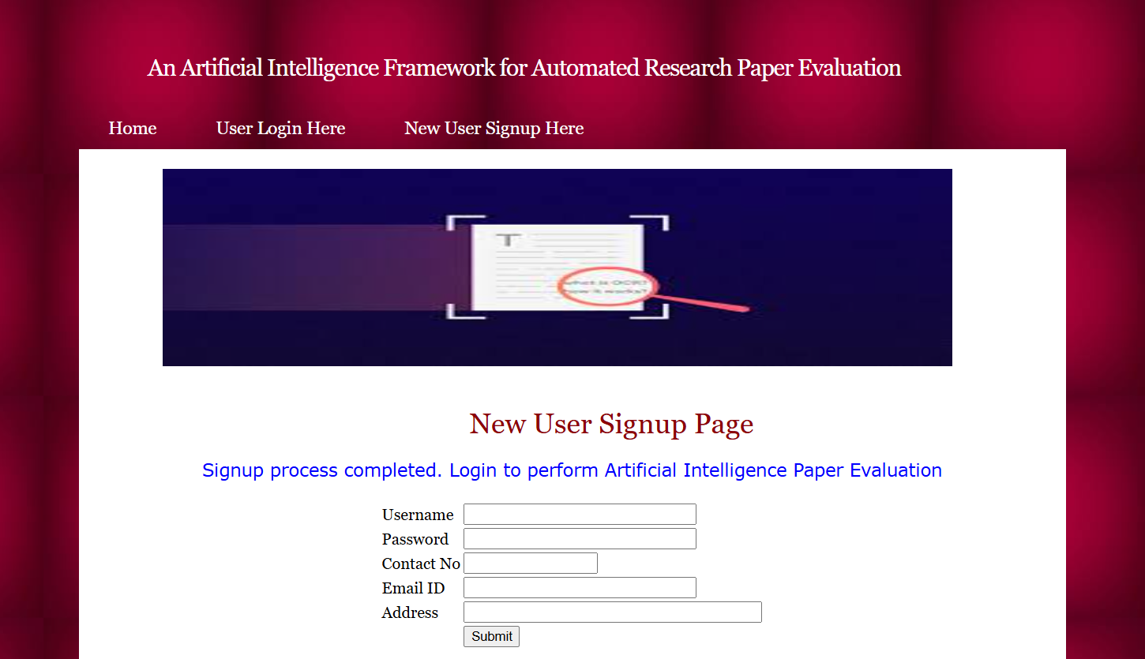
In above screen sign up task completed and now click on ‘User Login’ link to get below page
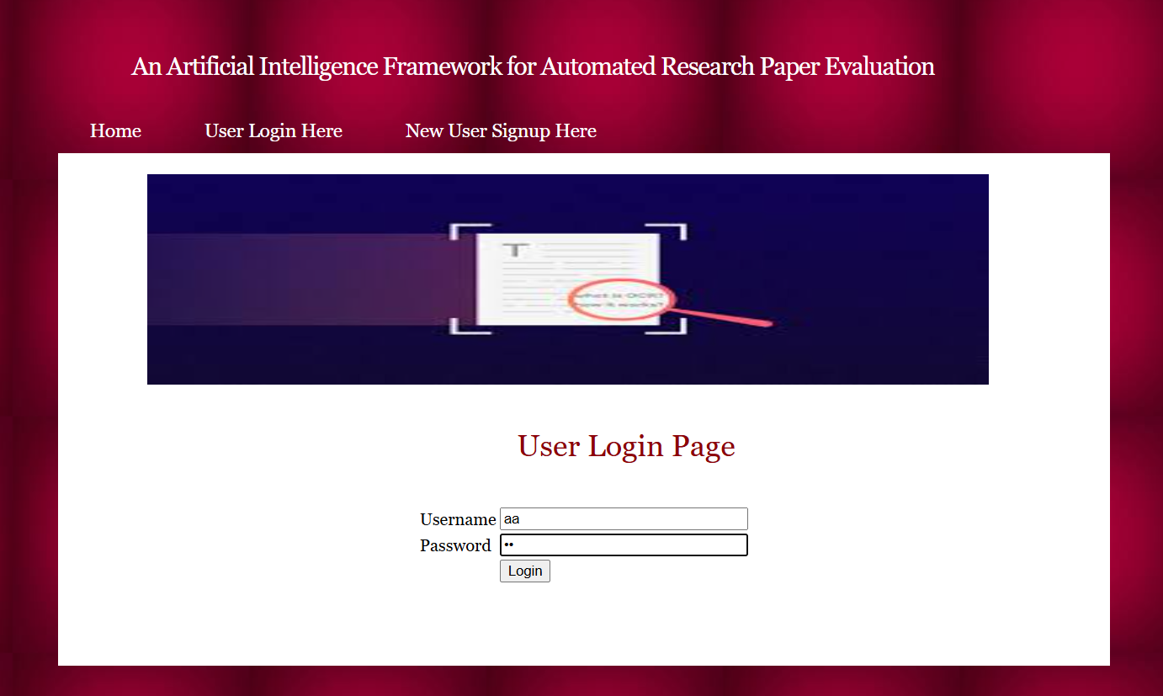
In above screen user is login and after login will get below page
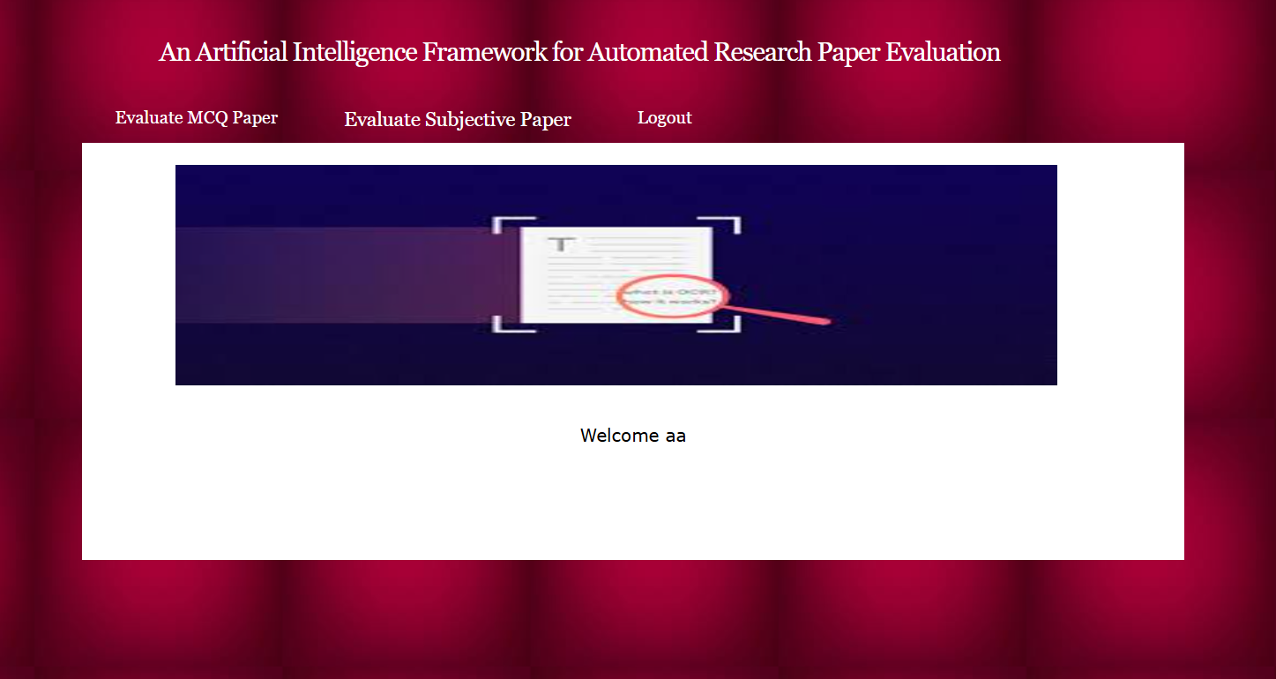
In above screen click on ‘Evaluate MCQ Paper’ link to get below page
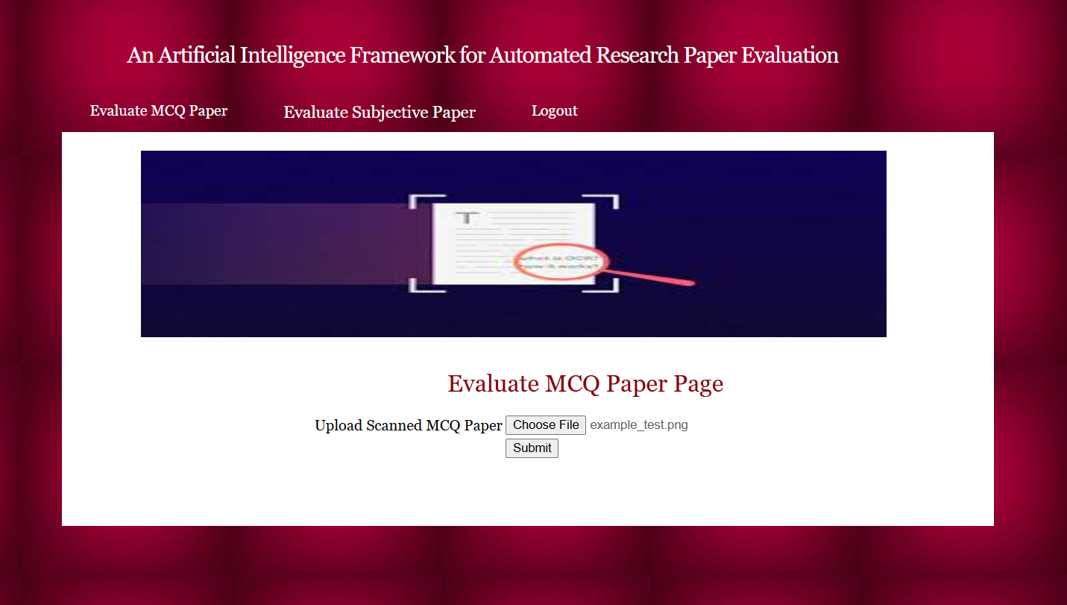
In above screen selecting and uploading MCQ paper and then press button to get below page
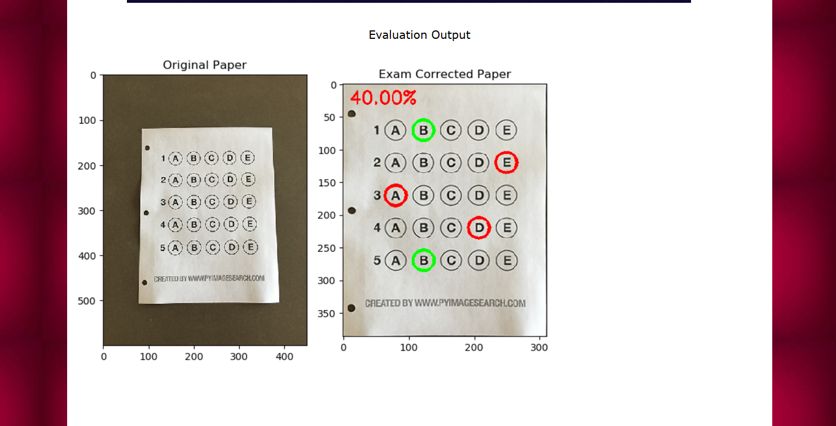
In above screen first image is the uploaded exam image and second image is the correction image along with marks where green circle represents correct answer and red circle represents incorrect answer given by student. Similarly you can upload and test other papers. Now click on ‘Evaluate Subjective Paper’ link to get below page
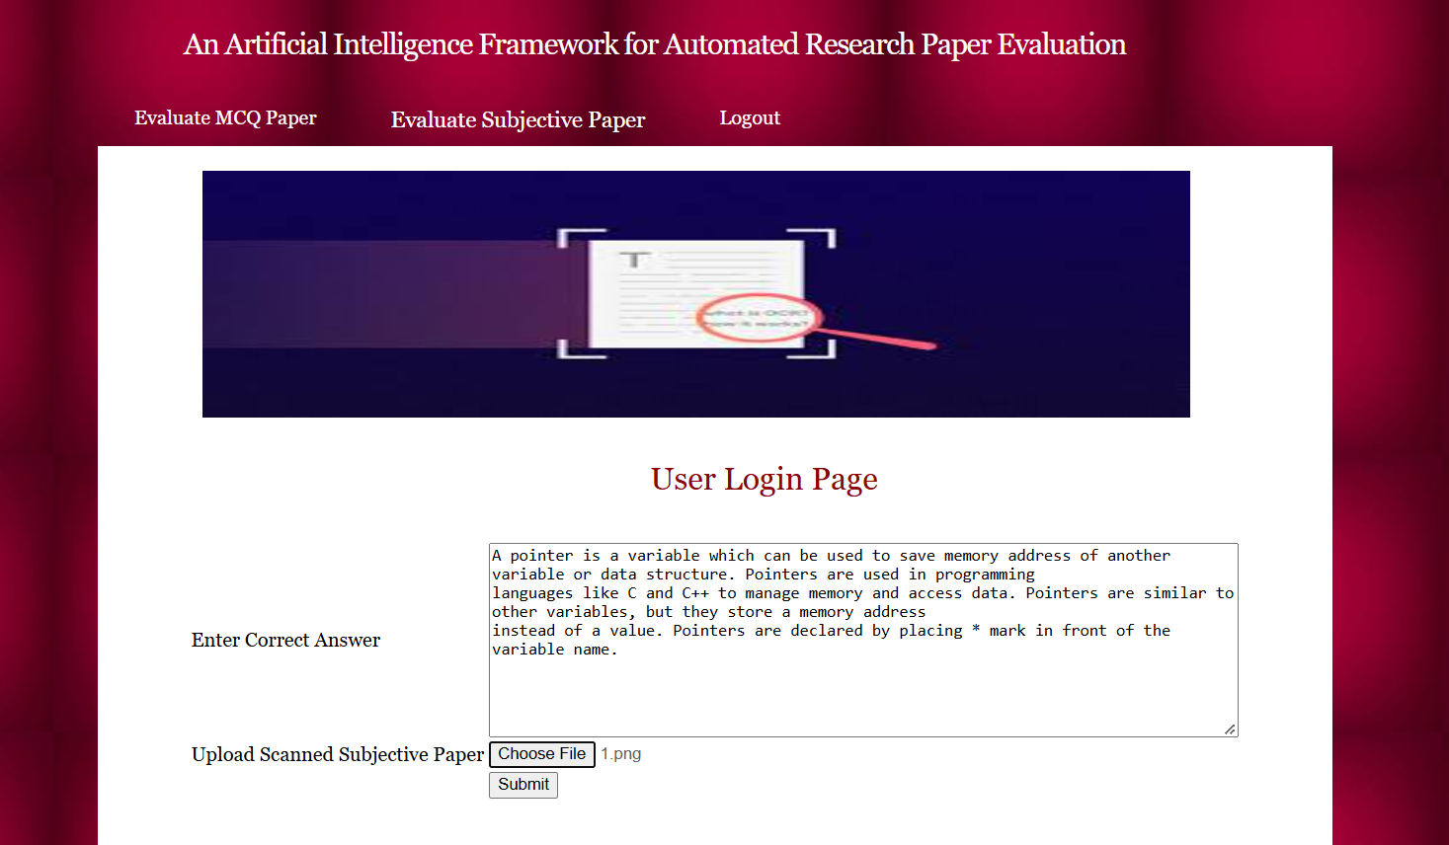
In above screen in first text area entered the correct subjective answer and then upload student subjective scanned image and then press button to get below page
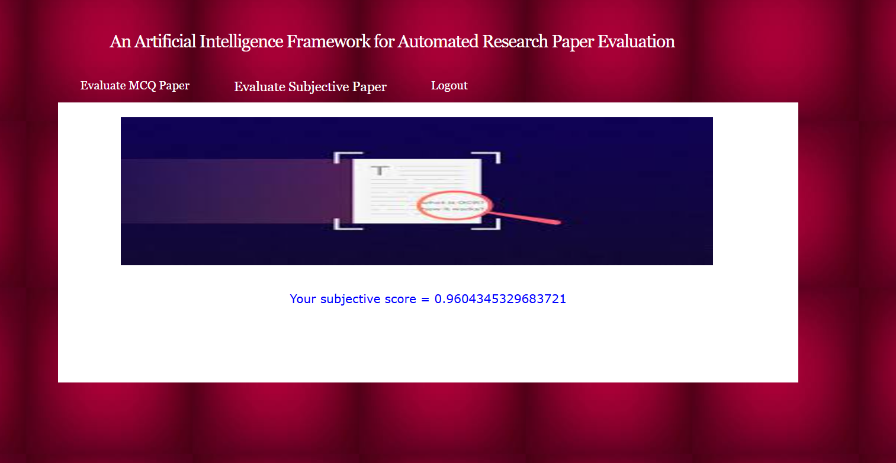
In above screen student got 96% score and similarly you can checked with any image

